Color Image Quality Assessment based on Structural Similarity
Lu Fang-fang(卢芳芳), Zhao Qun-fei(赵群飞), Yang Gen-ke(杨根科)
Department of Automation, Shanghai Jiaotong University, Shanghai 200240, China

Abstract: It is well-known that classical quality measures, such as the Mean Squared Error (MSE), Weighted Mean Squared Error (WMSE) or the Peak Signal-to-Noise Ratio (PSNR), not always correspond with visual observations. Structural Similarity based image quality assessment is proposed under the assumption that the Human Visual System (HVS) is highly adapted for extracting structural information from an image. While the demand on high color quality increases in the media industry, Color loss will make the visual quality different. In this paper, we propose an improved quality assessment method by adding color comparison into structural similarity measurement system for evaluating color image quality. Then we separate the task of similarity measurement into four comparisons: luminance, contrast, structure and color. Experimental results show that the predicted quality scores of the proposed method are more effective and consistent with visual quality than the classical methods using five different distortion types of color image sets.
Key words: Image quality assessment; structural similarity; difference mean opinion score; color image
CLC number: TP918.8 Document code: A
Article ID: 2753

Introduction
Digital images are subject to a wide variety of distortions during acquisition, processing, compression, restoration, transmission, storage and reproduction, any of which may result in a degradation of visual quality. The quality of an image is defined to be an impression of its merit or excellence, as perceived by an observer neither associated with the act of photography, nor closely involved with the subject matter depicted ^{[1]}.
There are two primary ways how to evaluate image quality, that is, subjective quality assessment (QA) and objective QA. Since human beings are the ultimate consumers of almost all of the image and video content, the obvious way of measuring quality is subjective QA. In practice, however, subjective QA is usually too inconvenient, time-consuming and expensive. And it cannot be easily embedded into image and video processing systems. So we should use objective QA to measure the image and video quality. The goal of objective image and video QA research is to design quality metrics that can predict perceived image and video quality automatically ^{[2]}.
According to the availability of a reference image, objective QA methods can be classified into three broad categories: full-reference QA methods, no-reference QA methods and reduced-reference QA methods ^{[2]}. In full-reference QA methods, a test image is evaluated by comparing it with a reference image that is assumed to have perfect quality. The general used methods of full-reference quality assessment, which are called the error sensitivity based methods, consider the test image signal as the sum of the reference image signal and an error signal. One problem with these methods is that larger visible differences may not necessarily imply lower perceptual quality. Classical quality measures, such as MSE, WMSE or PSNR, are simple to calculate, have clear physical meanings, and are mathematically convenient in the context of optimization ^{[3]}. But they are all error sensitivity based methods, and therefore not always correspond with visual observations. It is also important to recognize their limitations, such as the supra-threshold problem, the natural image complexity problem and so on as ^{[3]} mentions.
In the last three decades, a great deal of efforts have been made to develop new objective image/video quality methods that incorporate perceptual quality measures by considering HVS characteristics ^{[4]-[7]}. Structural similarity is presented as a novel philosophy for objective QA methods. It is different from and complementary to the typical HVS-based approaches, which usually calculate signal difference between the test and reference images, and attempt to quantify the difference “perceptually” by incorporating known HVS properties. In order to incorporate perceptual quality measures, Zhou Wang ^{[8]} first proposed a structural similarity (SSIM) measurement system for image quality assessment. The system includes three comparisons: luminance, contrast and structure. By deeply studying the SSIM, Guan-Hao Chen et al. found it fails in measuring the badly blurred images, and develop an improved method which is called Edge-based Structural Similarity (ESSIM) ^{[9]}.
Although the values of mean structural similarity (MSSIM) exhibit much better consistent with the qualitative visual appearance than other image quality methods based on error sensitivity, they use the luminance component only for color image quality assessment. An example is shown in Fig. 1, where the original image is distorted by different noise, each to yield nearly identical standard deviation relative to the original image. Fig. 1(b) is distorted by uncolored noise, while Fig. 1(c) and (d) are distorted by some color noise and more color noise, respectively. Except for the different color of the noise, Fig. 1(b) and (c) almost have the same noise, but we can see that the two images have drastically different perceptual quality. As shown in Fig.1, color difference makes the images with same standard deviation look different. So we should consider color comparison for measuring color image quality.

(a) (b)
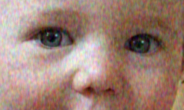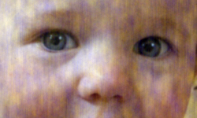
- (d)
Fig. 1 Different looks with same standard deviation (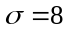). (a) Original image (b) Uncolored noise distorted image (c) Some color noise distorted image (d) More color noise distorted image

In this paper, we propose an improved quality assessment method by adding color comparison into structural similarity measurement system for evaluating color image quality. Then we separate the task of similarity measurement into four comparisons: luminance, contrast, structure and color. We use five different distortion types of image sets to evaluate the performance of the proposed method. The experimental results show that the predicted quality scores are more effective and consistent with visual quality than PSNR, MSSIM and ESSIM for color images.
The rest of the paper is organized as follows: Section 1 describes the paradigm of the proposed image quality assessment method. Then Section 2 gives experimental results of PSNR, MSSIM, ESSIM and the proposed method using five different distortion types of image sets in LIVE image quality assessment database ^{[10]}. In Section 3, we evaluate the performance of the proposed method with PSNR, MSSIM and ESSIM relative to subjective scores from human observers. Finally, Section 4 concludes this paper.
- Color-based Structural Similarity Image Quality Assessment
  - Color comparison
Measuring color in the media industry becomes more and more essential while the demand on high color quality increases. Color loss refers to the relationship between colors in an original image and the corresponding colors depicted in an image after distortion. The visual assessment or the densitometric measurement has been the most common methods in use to evaluate the color difference between two images in last century. But later, the use of colorimetry and spectrophotometric measurements are more frequent in the production of printed media. We use colorimetric measurement to compute the color difference between the test and reference images. Color difference can be computed in a variety of color spaces, but preferably used in CIELAB color space that is more appropriate for the HVS. The most widely used color difference equations in the last decades are CIELAB and CIELUV color difference equations recommended in 1986 by the Commission Internationale de l'Eclairage (CIE) ^{[11]}. In 1976, McLaren first introduced weighting factors for each dimension of color in his color difference equation ^{[12]}. In 1994, CIE proposed a new color difference called CIE94 ^{[13]}. The CIE2000 color difference is the last formulation of corrections designed to improve the earlier color difference equations based on predetermined color data sets ^{[14]}.
Generally speaking, digital images are initially represented in RGB color space. Although the CIE2000 color difference formula is in form with more consistent trends in lightness and hue-angle dependencies, after considering the computational complexity of the formula, we choose CIELAB color difference equations recommended by the CIE in 1986 as the simple one.
Suppose and are two color image signals, which have been aligned with each other (e.g. spatial patches extracted from each image). Then the color difference in CIELAB color space between them is given by Eq. (1).

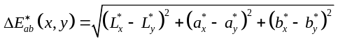 (1)

where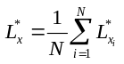, 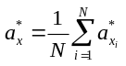, 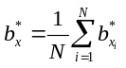, is the number of pixels of ; 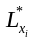, 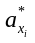and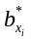 are respectively the lightness, the redness-greenness and yellowness-blueness scales of in CIELAB color space; 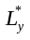, 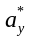 and are the three corresponding scales of in CIELAB color space.
Then a color comparison function is defined as follows:

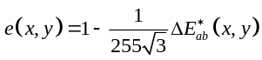 (2)

where 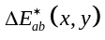 is the color difference between two color image signals and in CIELAB color space as Eq. (1) defined.
Then the color comparison 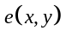 satisfies the following conditions.
- Symmetry: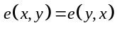.
- Boundedness: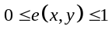.
- Unique maximum: 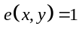 if and only if (in discrete representations, 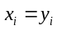 for all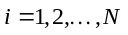).
  - Color-based structural similarity image QA
For evaluating color image quality, color comparison is added into structural similarity measurement system. So we separate the task of similarity measurement into four comparisons: luminance, contrast, structure and color. The diagram of the color-based structural similarity (CSSIM) measurement system is shown in Fig.2.
Suppose and are two color image signals, which have been aligned with each other (e.g. spatial patches extracted from each image). According to ^{[3]}, the luminance, contrast and structure comparison function are defined as follows:

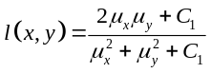 (3)

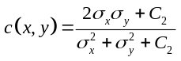 (4)

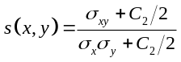 (5)

where 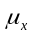 and 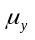 are the mean value of luminance component of two color image signals; 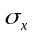and 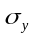 are the standard deviation of luminance component of two color image signals; 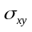is the covariance of luminance component of two color image signals; the constant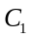and 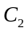 are included to avoid instability when denominator is very close to zero.
Then the four components are combined to yield an overall similarity measure

(6)

where , , and are positive number. We set 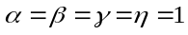 in order to simplify the expression. Then the simplification of SSIM is as follows:

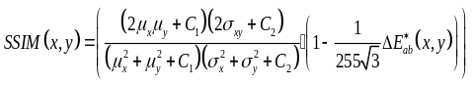 (7)

In practice, one usually requires a single overall quality measure of the entire image. We use a mean SSIM index to evaluate the overall image quality

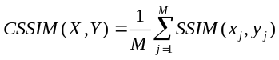 (8)
where and are the reference and test images, respectively; 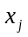and 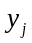 are the image contents at the th local window; and is the number of local window of the image.
- Experimental Results And Analysis
In this section, we will show some experimental results. The image database used in the experiment is from ^{[10]}, which consists of 29 original high-resolution 24-bits/pixel RGB color images. It includes five different distortion types of image sets. The detail of the image database is shown in Table 1. We only use the total of 779 distorted images in our experiment.
Table 1 LIVE Image QA Database
Image set | Number of distorted images | Number of undistorted images | Total Number of images
JPEG | 175 | 58 | 233
JPEG2000 | 169 | 58 | 227
White Noise | 145 | 29 | 174
Gaussian Blur | 145 | 29 | 174
Fast Fading | 145 | 29 | 174
Total | 779 | 203 | 982

In order to compare with MSSIM and ESSIM, we also scale and shift the CSSIM to the full range (0-1). Fig. 3 is the experimental results of sample JPEG compressed images with different compressed ratios. As shown in Fig. 3, the PSNR and ESSIM values can be found to varying degrees in lower than perceptual quality; while the MSSIM values can be found to varying degrees in higher than perceptual quality. For example, Fig. 3 (b) has poor quality, but MSSIM gets good quality score, and CSSIM gets low quality score which is more consistent with human perception. And Fig. 3 (f) has good quality, but PSNR and ESSIM gets poor quality score, and CSSIM gets good quality score. It is clearly that the prediction of the proposed method can be more consistent with perceptual quality score.
For the database, about 25 human observers rated each image. The raw scores for each observer are converted to Z scores and then scaled and shifted to the full range (0-100). Difference Mean Opinion Score (DMOS) is the difference mean opinion score between the source image data and the processed image data. Then DMOS is computed for each image.
The quality predictions, after compensating for the mapping, are shown in Fig. 4 to Fig. 8. The mapping function used is given in (9), while the fitting was done using MATLAB’s fminsearch.
Fig. 4(a)-(d) are respectively the scatter plots for the quality predictions by PSNR, MSSIM, ESSIM and CSSIM after compensating for quality calibration using JPEG compressed images with different compressed ratios in the image database. Fig. 5(a)-(d) are respectively the scatter plots for the quality predictions by PSNR, MSSIM, ESSIM and CSSIM after compensating for quality calibration using JPEG2000 compressed images with different compressed ratios in the image database. As shown in Fig. 4, MSSIM performs much better than PSNR and ESSIM. However, during our study, we find that JPEG compressed images cause color loss along with high compressed ratio. By adding color comparison, CSSIM performs much better than MSSIM not only in JPEG compressed image set but also in JPEG2000 compressed image set as shown in Fig. 4 and Fig. 5, respectively.

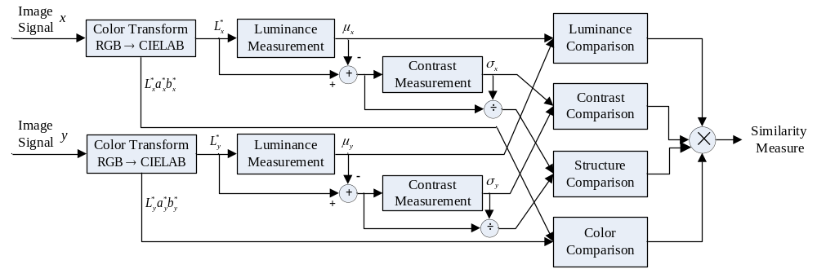
Fig. 2 Diagram of the color-based structural similarity (CSSIM) measurement system.

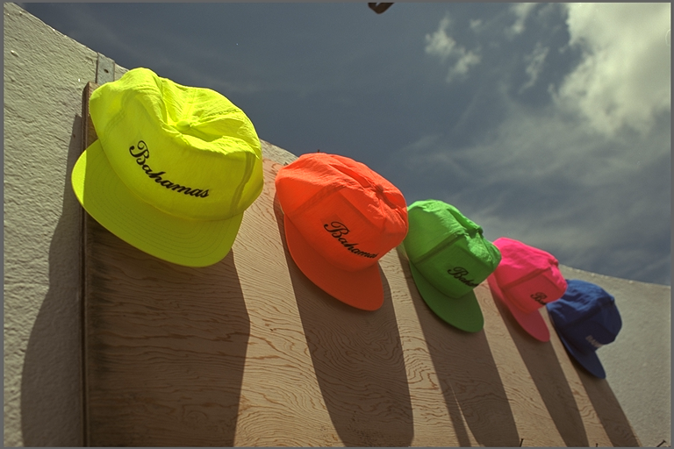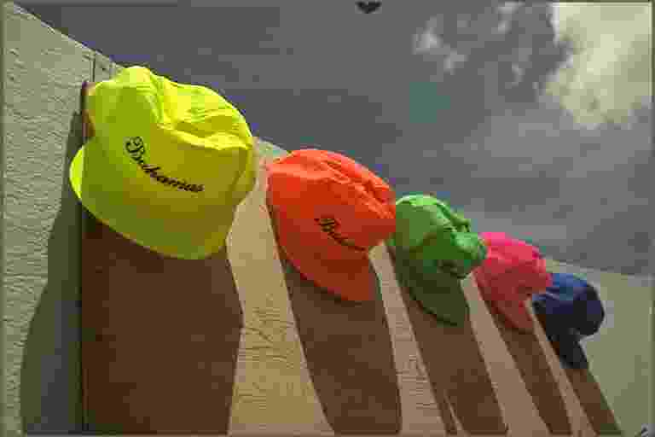
(a) (b) (c)
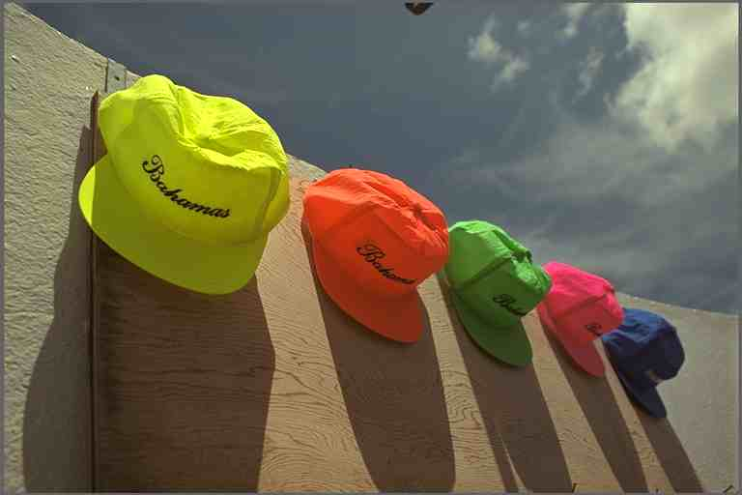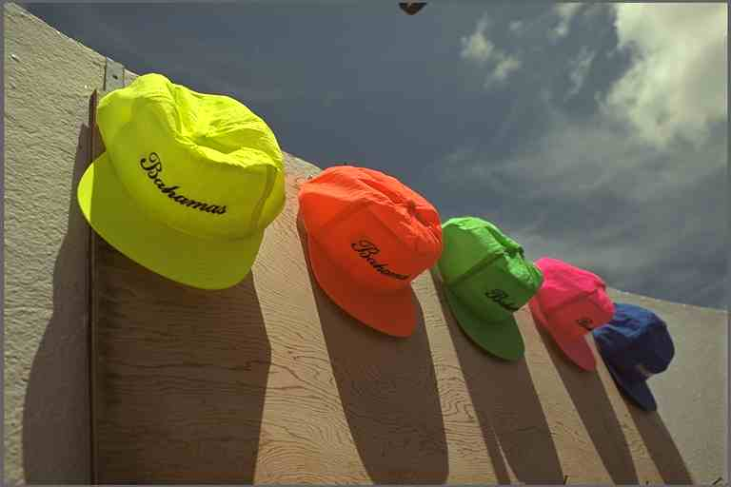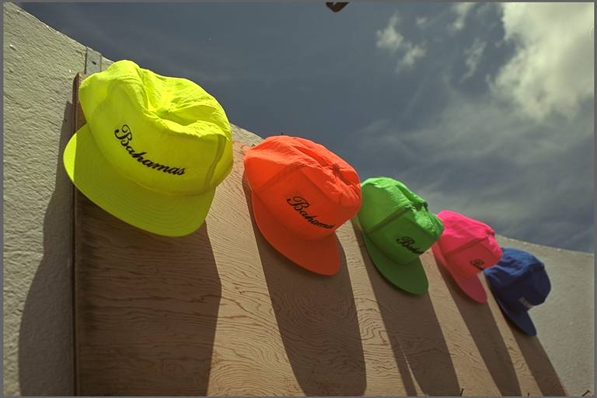
(d) (e) (f)
Fig. 3 Experimental results of sample JPEG compressed images with different compressed ratios. (a) Original image
(b) Compressed to 0.1531 bits/pixel, PSNR=25.83 dB, MSSIM=0.7189, ESSIM=0.3616, CSSIM=0.3605.
(c) Compressed to 0.1993 bits/pixel, PSNR=29.39 dB, MSSIM=0.7841, ESSIM=0.4208, CSSIM=0.5735.
(d) Compressed to 0.4054 bits/pixel, PSNR=34.06 dB, MSSIM=0.9003, ESSIM=0.4488, CSSIM=0.7242.
(e) Compressed to 0.4248 bits/pixel, PSNR=34.33 dB, MSSIM=0.9053, ESSIM=0.4599, CSSIM=0.7511.
(f) Compressed to 0.8512 bits/pixel, PSNR=38.26 dB, MSSIM=0.9553, ESSIM=0.6518, CSSIM=0.9028.

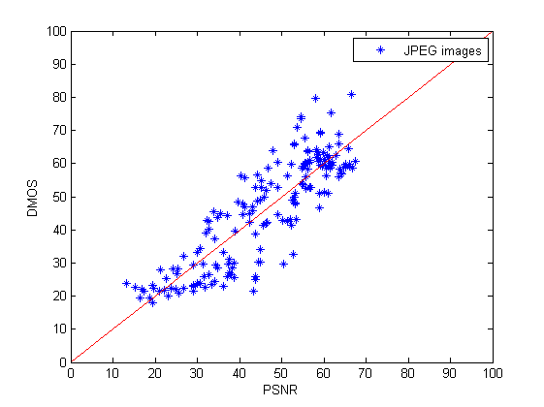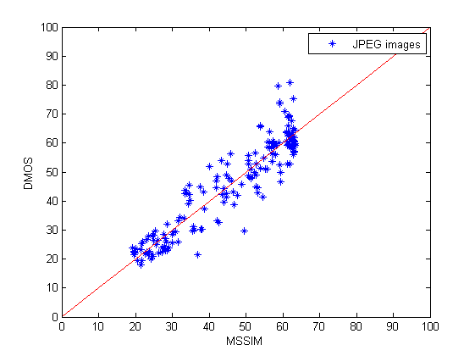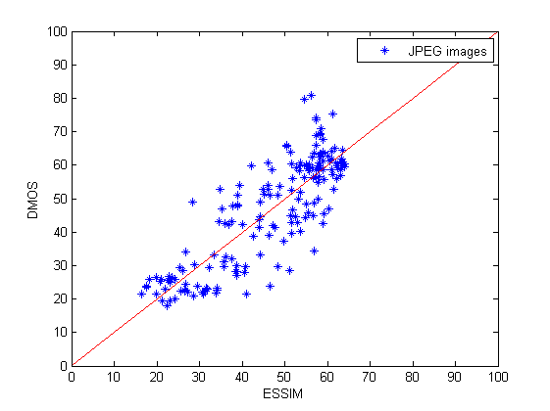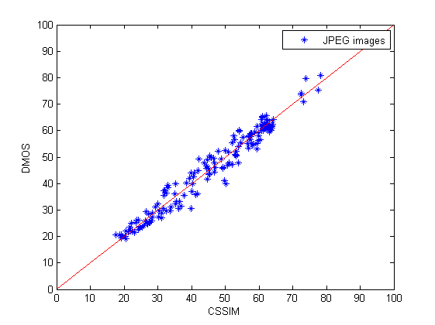
(a) (b) (c) (d)
Fig. 4 Scatter plots for the quality predictions by the four methods after compensating for quality calibration: PSNR, MSSIM, ESSIM and CSSIM for JPEG compressed images with different compressed ratios.
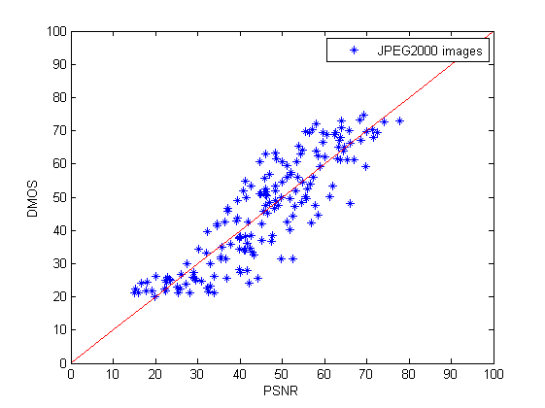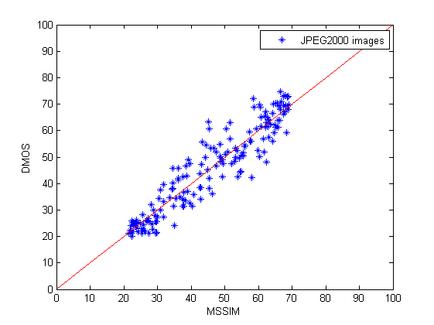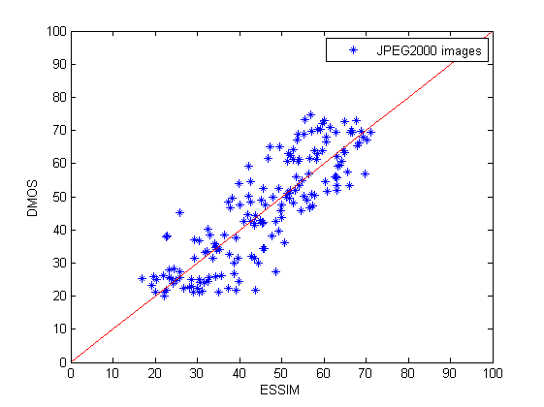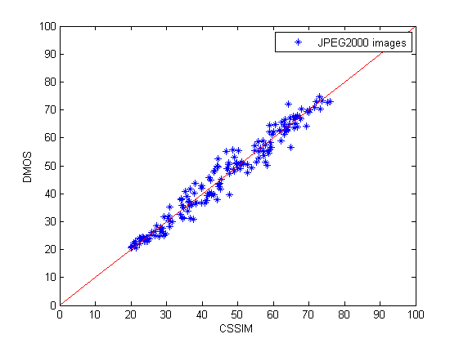
(a) (b) (c) (d)
Fig. 5 Scatter plots for the quality predictions by the four methods after compensating for quality calibration: PSNR, MSSIM, ESSIM and CSSIM for JPEG2000 compressed images with different compressed ratios.
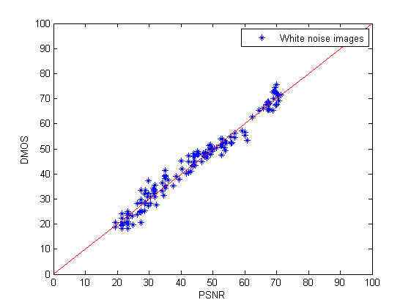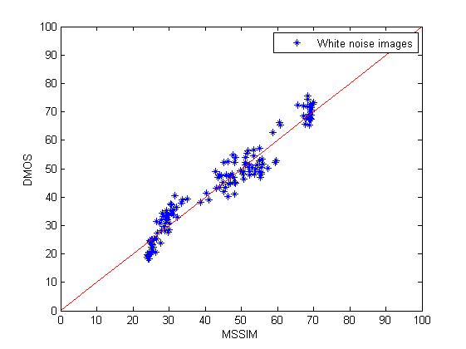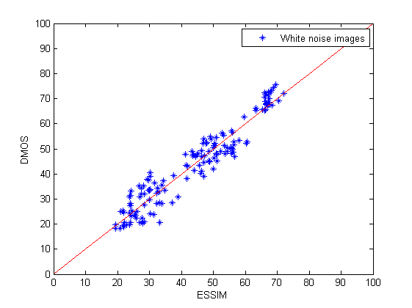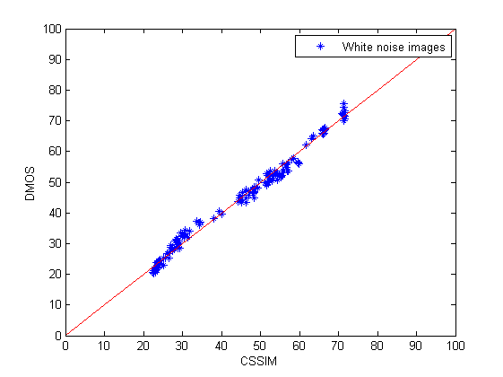
(a) (b) (c) (d)
Fig. 6 Scatter plots for the quality predictions by the four methods after compensating for quality calibration: PSNR, MSSIM, ESSIM and CSSIM for white noise distorted images.
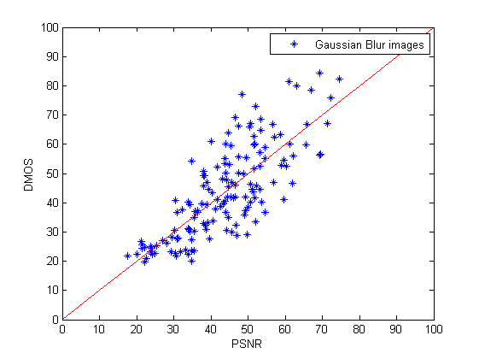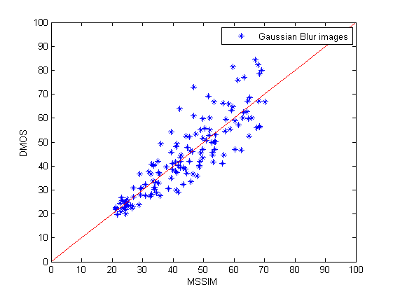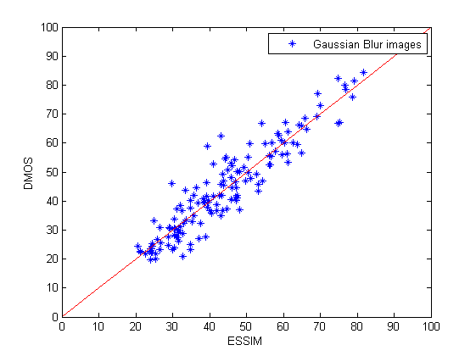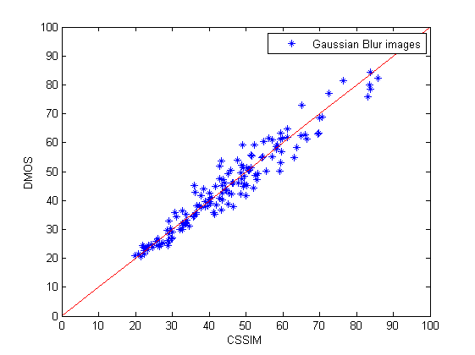
(a) (b) (c) (d)
Fig. 7 Scatter plots for the quality predictions by the four methods after compensating for quality calibration: PSNR, MSSIM, ESSIM and CSSIM for Gaussian blur distorted images.
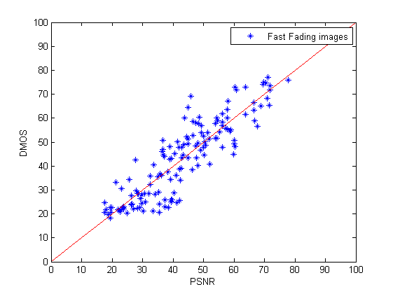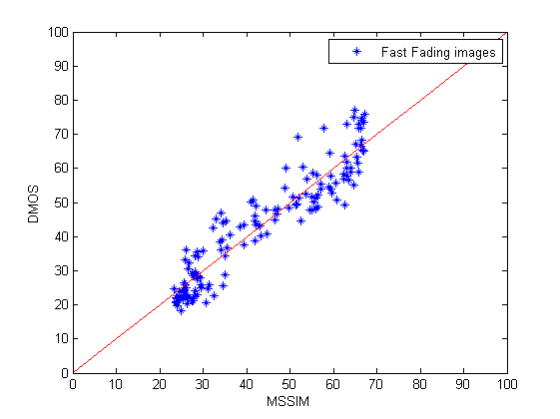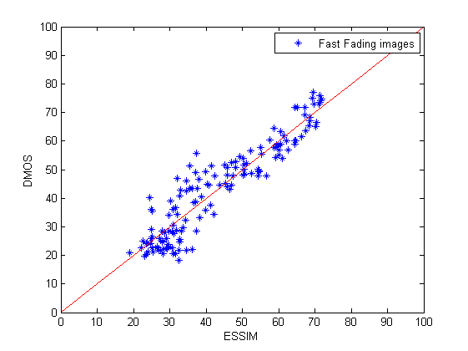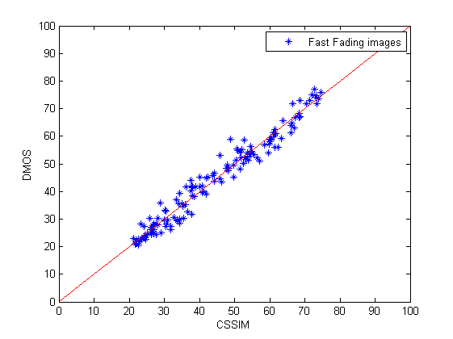
(a) (b) (c) (d)
Fig. 8 Scatter plots for the quality predictions by the four methods after compensating for quality calibration: PSNR, MSSIM, ESSIM and CSSIM for fast fading distorted images.

Fig. 6(a)-(d) are the scatter plots for the quality predictions by PSNR, MSSIM, ESSIM and CSSIM after compensating for quality calibration using white noise distorted images in the image database, respectively. As shown in Fig. 6, PSNR performs better than MSSIM and ESSIM. It is clearly that PSNR is more suitable for assessing white noise distorted images than MSSIM. We can also get the same conclusion that CSSIM supplies remarkably better predictions of the subjective scores than PSNR, MSSIM and ESSIM.
Fig. 7(a)-(d) are, respectively, the scatter plots for the quality predictions by PSNR, MSSIM, ESSIM and CSSIM after compensating for quality calibration using Gaussian blurring distorted images in the image database. As shown in Fig. 7, ESSIM performs better than MSSIM and PSNR. Fig.8(a)-(d) are the scatter plots for the quality predictions by PSNR, MSSIM, ESSIM and CSSIM after compensating for quality calibration using fast fading distorted images in the image database, respectively. By adding color comparison, CSSIM gives remarkably better predictions of the subjective scores than PSNR, MSSIM and ESSIM.
- Performance Evaluation
We choose two metrics to evaluate the performance of the proposed quality assessment method. A nonlinear regression function is used to transform the set of CSSIM values to set of predicted MOS (DMOS_{p}) values, which are then compared with the actual DMOS values from the subjective tests.
The nonlinear regression function ^{[15]} is defined by Eq. (9).
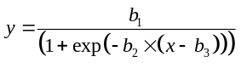 (9)

where and represent the raw CSSIM values and the predicted MOS (DMOS_{p}) values; ,and are three parameters.
Prediction accuracy is the ability of the metric to predict subjective score with minimum average error and can be determined by means of Pearson linear correlation coefficient, which is defined as

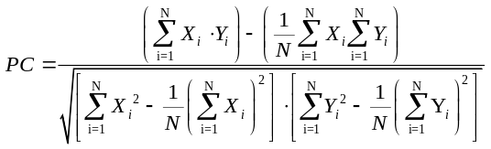 (10)

where 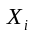 can be considered as a result from subjective image quality scores, DMOS; as the predicted MOS values, DMOS_{p}; and is the number of values in each data set.
The Pearson linear correlation coefficients for all the four models are compared in Table 2.
As shown in table 2, MSSIM almost performs better than PSNR, except for evaluating white noise distorted images. It shows that PSNR is more suitable for evaluating white noise distorted images. And ESSIM performs better than MSSIM using Gaussian blur distorted images. We can also see that CSSIM performs better than all of the other three compared models using five different distortion types of image sets. So CSSIM has better prediction accuracy than PSNR, MSSIM and ESSIM, and the predicted quality scores are more consistent with human perception.
Table 2 Pearson Linear Correlation Coefficient
Image set | PSNR | MSSIM | ESSIM | CSSIM
JPEG | 0.8600 | 0.9277 | 0.8349 | 0.9802
JPEG2000 | 0.8808 | 0.9360 | 0.8453 | 0.9823
White Noise | 0.9857 | 0.9693 | 0.9561 | 0.9940
Gaussian Blur | 0.7833 | 0.8739 | 0.9307 | 0.9665
Fast Fading | 0.8862 | 0.9375 | 0.9300 | 0.9831

Prediction monotonicity is the degree to which the model’s predictions agree with the relative magnitudes of subjective quality scores ^{[15]}. One of the metrics relating to prediction monotonicity of a model is Spearman rank order correlation coefficient which is defined by Eq.(11).

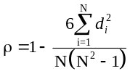 (11)

where is the difference between the ranks of corresponding values and , and is the number of values in each data set.
Table 3 Spearman Rank Order Correlation Coefficient
Image set | PSNR | MSSIM | ESSIM | CSSIM
JPEG | 0.8513 | 0.9026 | 0.8108 | 0.9701
JPEG2000 | 0.8830 | 0.9317 | 0.8543 | 0.9798
White Noise | 0.9856 | 0.9629 | 0.9411 | 0.9927
Gaussian Blur | 0.7813 | 0.8942 | 0.9177 | 0.9656
Fast Fading | 0.8907 | 0.9411 | 0.9191 | 0.9806

Table 3 is the Spearman Rank Order Correlation Coefficients (SROCC) for all compared models. SROCC operates only on the rank of the data points, ignoring the relative distance between data points ^{[16]}. Except for white noise distorted images, MSSIM performs better than PSNR. Although MSSIM performs better than ESSIM in other four different distortion types of image sets, ESSIM performs better than MSSIM using Gaussian blur distorted images. As Table 3 shows that CSSIM performs better than PSNR, MSSIM and ESSIM using five different distortion types of image set. So CSSIM has better prediction monotonicity than PSNR, MSSIM and ESSIM, and the predicted quality scores are more consistent with human observation.
- Conclusions
Measuring color in the media industry becomes more and more essential while the demand on high color quality increases. Color loss will make the visual quality different. But as we concern that most of the existing image QA methods for color images are worked with luminance opponent only. Based on this, we propose an improved QA method by adding color comparison into structural similarity measurement system for evaluating color image quality. Then we separate the task of similarity measurement into four comparisons: luminance, contrast, structure and color.
In our experiment, we use five different distortion types of image sets to evaluate the effectiveness and robustness of the proposed method. Compared with PSNR, MSSIM and ESSIM, CSSIM predicts good results as shown in Fig. 4-Fig. 8. The major result of the proposed method is the possibility of evaluating image quality consistently with human perception for color images. As shown in table 2 and 3, CSSIM also has better performance than PSNR, MSSIM and ESSIM. Experimental evidence confirms that the proposed method provides a satisfactory approximation of the actual subjective scores.
References
[1] B W Keelan. Handbook of Image Quality: Characterization and Prediction [M]. New York: Marcel Dekker Inc., 2002: 9.
[2] A. C Bovik. Introduction to Image and Video Quality Assessment[OL]. [2009-3-17]. http://live.ece.utexas.edu/re-
search/quality/intro.htm.
[3] Z Wang, A. C Bovik, H R Sheikh, et al. Image Quality Assessment: From Error Visibility to Structural Similarity [J]. IEEE Trans. Image Process., 2004, 13(4): 600-612.
[4] C J van den Branden Lambrecht, Ed. Special Issue on Image and Video Quality Metrics [J]. Signal Process., 1998, 70(3): 155-294.
[5] VQEG. Final Report from the Video Quality Experts Group on the Validation of Objective Models of Video Quality Assessment [OL]. (2000-3-15) [2009-3-17]. http://www.it- s.bldrdoc.gov/vqeg/projects/frtv_phaseI/COM-80E_final_report.pdf.
[6] T N Pappas and R J Safranek. Perceptual Criteria for Image Quality Evaluation. In: A. C Bovik, ed. Handbook of Image &Video Processing [M]. San Diego: Academic Press, 2000: 669-684.
[7] Z Wang and A. C Bovik. Why is Image Quality Assessment so Difficult? [C]. Proc. of the IEEE ICASSP 2002, Orlando, Florida, 2002: IV-3313- IV-3316.
[8] Z Wang and A C Bovik. A Universal Image Quality Index [J]. IEEE Signal Processing Letters, 2002, 9(3): 81-84.
[9] G H Chen, C L Yang, L M Po, et al. Edge-based Structural Similarity for Image Quality Assessment [C]. ICASSP, Toulouse, France, 2006: II-933-II936.
[10] H R Sheikh, Z Wang, L Cormack, et al. LIVE Image Quality Assessment Database [OL]. (2005-2-13)[2009-3-17] http://live.ece.utexas.edu/research/quality/.
[11] Commission Internationale d'Eclairage. CIE Publication No.15.2, Colorimetry [S]. 2nd Ed. Vienna: CIE Central Bureau, 1986.
[12] K McLaren. An Introduction to Instrumental Shade Passing and Sorting and a Review of Recent Develop- ments [J]. J. Soc. Dyers Colour, 1976, 92(9): 317-326.
[13] Commission Internationale d'Eclairage. CIE Publication No. 116, Industrial Colour-Difference Evaluation [S]. Vienna: CIE Central Bureau, 1995.
[14] Commission Internationale d'Eclairage. CIE Publication No. TC1. 47, Hue and Lightness Correction to Industrial Colour Difference Evaluation [S]. Vienna: CIE Central Bureau, 2000.
[15] VQEG. Final Report from the Video Quality Experts Group on the Validation of Objective Models of Video Quality Assessment, Phase Ⅱ VQEG [OL]. (2003-8-25) [2009-3-17]. http://www.its.bldrdoc.gov/vqeg/projects/frtv- _phaseII/downloads/VQEGII_Final_Report.pdf.
[16] H R Sheikh, M F Sabir, and A C Bovik. A Statistical Evaluation of Recent Full Reference Image Quality Assessment Algorithms [J]. IEEE Trans. Image Process., 2006, 15(11): 3441-3452.

